## The Traffic Light Controller

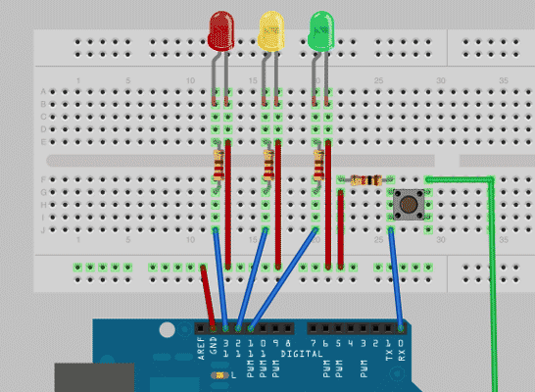

This super simple project is a great introduction to Arduino programming. The [**traffic light controller**](https://www.makeuseof.com/tag/arduino-traffic-light-controller/) uses a red, yellow, and green LED to re-create a traffic light on your breadboard, and give you the opportunity to hack the code in order to adjust the output, timing or even the sequence itself. It’s a wonderfully easy way to get your hands wet with simple coding, and learn to modify it to fit your goals for a particular project.

## Companion Cube Mood Lamp

This [**Portal-themed mood lamp**](https://www.makeuseof.com/tag/build-companion-cube-mood-lamp/) uses a square glass jar to create a color-shifting display that looks incredible in any dark room. The project itself is ideal for an Arduino beginner and most of the parts are included in your Arduino starter kit. Creating the lamp is a great starting point for beginners as the wiring, build and the code are relatively simple and a great way to slowly build into more advanced projects by learning some [**essential beginner’s electronics skills**](https://www.makeuseof.com/tag/beginners-electronics-10-skills-you-need-to-know/) that you can call on later

. *To build the lamp, you’ll need:*

* Square glass jar or bottle
* Hard-drying clear glue
* Gray and red modeling clay
* White candle

## Arduino-Powered Temperature Controller

On the Pacific Coast of Mexico, where I live, the average year-’round temperature hovers at a pleasant 70-degrees, making central air or heat a relatively rare occurrence. I’m not complaining, and generally the temperature doesn’t warrant any sort of need for control, but certain instances (growing plants indoors, cooling items in a mini-fridge to a set temperature, controlling surface temperature of a reptile cage, etc.) could require the need for a more constant temperature. With an Arduino, and a few parts, you’ll be well on your way to [**creating your own instead temperature control device**](https://www.makeuseof.com/tag/make-your-own-temperature-controller-with-an-arduino/) instead of forking over two or three times as much (or more) on a pre- built model.

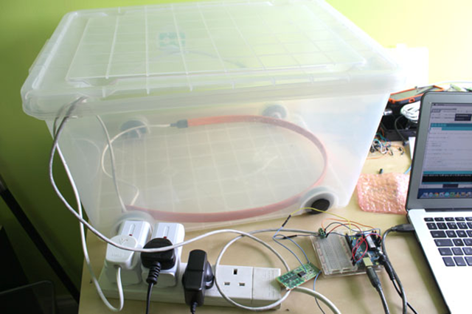

Additionally, this tutorial is a valuable launching point for projects with real world application, and electronics projects that rest firmly outside of simple Arduino-related tasks.

*You’ll need:*

* Temperature sensor, such as the TMP36
* Relay or RC plug switches
* Screw terminals
* Box to trap the heat
* Heating/cooling element, or incandescent bulb with fixture (or both)

## “The TV Devil” Arduino Prank Remote

This simple project allows you to use an IR (infared) remote in order to program a receiver to create a moderate amount of innocent chaos using anything that you can control with an IR remote. This particular project details the process of [**building a remote control**](https://www.makeuseof.com/tag/introducing-the-tv-devil-an-easy-remote-control-arduino-prank/)that makes your television seem as if it has a mind of its own while it switches channels at random, turns itself on and off, or just generally acts as if it has a mind of its own.

The prank itself is a great intro to learning the basics of IR control and receivers, which will lead you into more advanced projects like creating a Siri-controlled remote. But, before we walk we must learn to crawl, and this is a good place to start.

*What you’ll need to build the TV Devil:*

* [**IR remote library by Ken Shirriff**](https://github.com/shirriff/Arduino-IRremote) (via Github)
* IR transmitter LED, such as TIL38
* IR receiver, such as TSOP382

From internet: https://www.makeuseof.com/tag/10-great-arduino-projects-for-beginners/